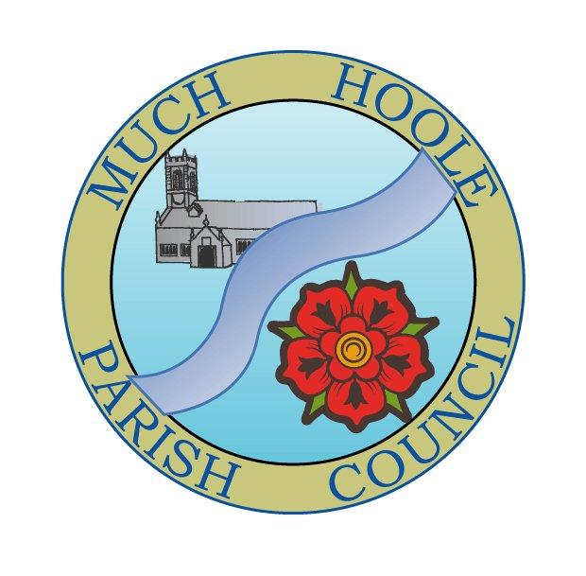 | MUCH HOOLE PARISH COUNCIL  NOTICE OF MEETING
You are hereby summoned to attend the Meeting of Much Hoole Parish Council to be held at 7.30pm on Monday 13th December 2021. The meeting will be held at the Venue (Hoole memorial village hall) Liverpool Road.
Russ Weaver, Clerk

AGENDA
1. | Apologies for Absence  To receive apologies for absence.
2. | Declaration of Interests and Dispensations  - To receive declarations of interest from Councillors on items on the agenda  - To receive written requests for dispensations for disclosable pecuniary interests (if any)  - To grant any requests for dispensation as appropriate
3. | Minutes of the Previous Meetings  To resolve to approve as a correct record the Minutes of the Council Meeting held on the 8th November 2021
4. | Public Time  To invite and listen to issues raised by members of the public.
5. | Off Road Cycle Track  To consider any updates on the Cycle track and resolve any actions required.
6. | Finance and Audit  To resolve to authorise payment of the following:  - To resolve to pay the clerk salary in the sum of £240 (net) for November  - To resolve to pay the Clerk expenses for mileage for October in sum of £23.99  - To resolve to pay HMRC in sum of £60 PAYE for November  - To resolve to pay invoices 111 & 112 for Lengthsman in sum of £25 & £78.24 (TOTAL £103.24)  - To note the latest budget against spend summary.  - To note the bank reconciliation as at 5th December 2021
7. | 2022/2023 Budget  To consider the first draft budget, make any alterations as necessary and set the budget and precept for 2022/23
8. | Grant Applications  To consider the attached grant application from Much Hoole Village shop for a replacement community notice board in sum of approximately £150 (subject to invoice)
9. | Community Projects update  To receive an update on any ongoing projects
10. | Planning  07/2021/01087/DIS October 19, 2021 Application to Discharge Condition No. 3, 4  (Drainage) and 6 (Biodiversity Enhancement) of planning permission 07/2021/00614/FUL  Plum Farm, 33 Town Lane’ Much Hoole, Preston, Lancashire, PR4 4GJ
11. | Casual Vacancy  Councillor Chris Hewitt has been unable to attend 6 consecutive meetings and has indicated he wishes to step down from the Council. The Council now needs to note his resignation and commence the process for filling a casual vacancy.
12. | Village Hall development update  To receive and note a report on the progress of The Venue
13. | Christmas decorations  Councillors have a budget available to spend on Christmas decorations (agreed in December 2020) and can determine at this meeting how it is to be spent for2021.
14. | Reports from other meetings  The Council will receive reports from meetings where Councillors have attended as representatives
15. | Items for next agenda  Jubilee lunch  Remembrance day 2022  Annual Review of: Standing orders, risk register, financial regulations, asset register.
16. | Date of Next Meeting  The Parish Council to agree the date of the next meeting as 7.30pm Monday 10th January 2022, to be held at ‘The Venue’, Liverpool Road, Much Hoole.

